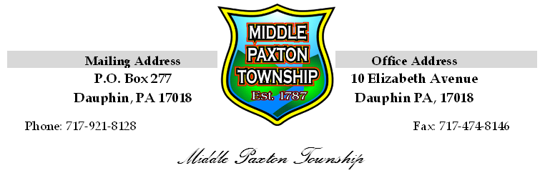
MIDDLE PAXTON TOWNSHIP

Planning Commission

Meeting Minutes

November 13, 2017

The November 13, 2017 meeting of the Middle Paxton Township Planning Commission was called to order at 7:00 p.m. by Chairperson Liz Rodda. The following members were present: Gary Deimler, Ralph Stone, Jeffrey Smith, and Bill Kotkiewicz.

Also present were Julie Seeds, Recording Secretary and Ed Fisher, Township Representative with Light- Heigel & Associates, Township Engineer.

Following the Pledge of Allegiance to the Flag, Mr. Stone moved to approve the meeting minutes for May 08, 2017, Seconded by Mr. Deimler. The motion carried unanimously.

OLD BUSINESS:
No Old Business

NEW BUSINESS:

Greg Schwartz with Snyder, Secary & Associates, LLC, was in attendance to present a Preliminary Subdivision and Land Development Plan dated 09/18/2017, for the plan, Parkway Estates for Calabria Estates, LLC. The purpose of the plan is to subdivide a 60.754 acre tract of land into 13 lots, including all related site improvements as required by the Subdivision and Land Development Ordinance of Middle Paxton Township and the Zoning Ordinance of Middle Paxton Township. The tract of land is located on the eastern side of Blue Mountain Parkway located off Route 443, Fishing Creek Valley Road. Mr. Schwartz stated it is the intention of the property owner/developer to dedicate the proposed road to the Township.

The Planning Commission reviewed the October 9, 2017 comment letter from Township Engineer, Light-Heigel & Associates, which consisted of twenty (20) Subdivision and Land Development Ordinance comments and twenty (20) Storm Water Ordinance comments. (See attached)

In addition, the Planning Commission reviewed the comment letter from the Township’s Zoning Officer, Matt Sauers, dated November 13, 2017 (See attached). A discussion ensued in regards to the zoning officer’s comment as it refers to minimum lot width of 200’as depicted on Table 3-1 and the definition of frontage versus lot width. In Mr. Sauers absence, Ms. Seeds was asked by the Planning Commission to review the definitions with the Township Solicitor for clarification.

Casey Baxendale with Tri County Regional Planning Commission reviewed her comments on the proposed preliminary plan and stated many were consistent with Light-Heigel’s comments and the Zoning Officer’s comment. (See attached)

Due to the numerous review comments from Light-Heigel & Associates, Inc., Tri County Planning Commission, and the Zoning Officer for Middle Paxton Township, Mr. Kotkiewicz motioned to table the Preliminary Subdivision and Land Development Plan, Seconded by Mr. Stone. The motion carried unanimously.

Mr. Greg Schwartz presented a letter dated November 13, 2017, on behalf of his client, Calabria Estates, LLC, the landowner, hereby granting Middle Paxton Township a time extension until February 6, 2018, to process the referenced Preliminary Subdivision and Land Development Plan for Park Estates, for Calabria Estates, LLC.

Comments
Ms. Seeds provided a list of projects the Township is currently working on with a brief update on the status of the projects.

There being no further business the meeting was adjourned at 8:04 p.m., Mr. Stone moved to adjourn the meeting, Seconded by Mr. Deimler. The motion carried unanimously.

Respectively Submitted,

Julie A. Seeds
Recording Secretary

