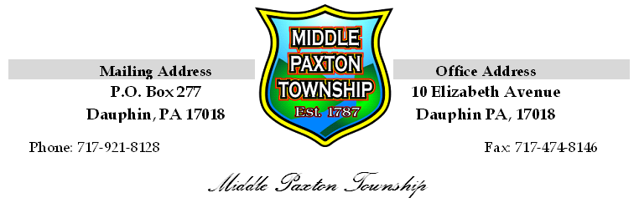
MIDDLE PAXTON TOWNSHIP

Planning Commission

Meeting Minutes

May 13, 2017

The March 13, 2017 meeting of the Middle Paxton Township Planning Commission was called to order at 7:00 p.m. by Chairperson Liz Rodda. The following members were present: Don Morse, Gary Deimler, Ralph Stone, Chip Brown, and Bill Kotkiewicz.

Also present were Julie Seeds, Recording Secretary and Ed Fisher, Township Representative with Light- Heigel & Associates and Casey Baxendale with Dauphin County Planning Commission.

Following the Pledge of Allegiance to the Flag, Mr. Brown moved to approve the meeting minutes for March 13, 2017, Seconded by Mr. Deimler. The motion carried unanimously.

OLD BUSINESS:

There was no old business

NEW BUSINESS:

Ms. Seeds presented a request from the Board of Supervisors for a review of the Zoning Ordinance as it pertains to placing a Recreational Vehicle camper on a lot within the Agricultural Rural Residential District (A.R.R.) for seasonal use. This request was initiated by a property owner who attended the
May 1, 2017 Board of Supervisors meeting and expressed dismay with the Zoning Officers interpretation of the definition of Campground.

After much discussion it was recommended by the consensus of the Planning Commission the definition of Campground in the Ordinance of Definition and the section in the Zoning Ordinance, Agricultural Rural Residential District (A.R.R), Article 3, Table 3-1, (6); be reviewed during the updating of the Zoning Ordinance that should occur this year.

In addition, it was also discussed by the Commission; the property owners can seek relief through the Zoning Hearing Board by appealing the Zoning Officer’s interpretation or by seeking a variance.

A Motion was made by Mr. Stone to recommend the property owner to seek relief through the Zoning Hearing process and also recommend the sections of the Zoning Ordinance that pertain to Campgrounds and the definition of Campground be reviewed by the Zoning Ordinance update committee, once established, Seconded by Mr. Deimler. The motion carried unanimously.

Comments

Ms. Seeds provided an update on a list of projects the Township is currently working on at this time.

Chip Brown discussed the Route 443 Exit road project that PennDOT is working on and the poor signage leading to near head-on collisions. Ms. Seeds will contact PennDOT to request better signage and flagging in this area during the road construction project.

There being no further business the meeting was adjourned at 7:50 p.m. Mr. Stone moved to adjourn the meeting, Seconded by Mr. Morse. The motion carried unanimously.

Respectively Submitted,

Julie A. Seeds

